**Issues:** More or Improved Parks and Green Spaces

**Keywords:**

| Park space, green space, natural preserves, Ahrens Park, outdoor gym equipment at Ahrens, Rock Creek Park, Arbor Lake, Arbor more nature, centrally located parks, arboretum, lake paved path, public gardens botanic gardens, trails, hiking trails, running trails, trail, biking trails |
| --- |

**What are respondents of this category saying in Q1-5?**

**Removed words:** 'community', 'town', 'small', 'people', 'college', 'grinnell', 'job'

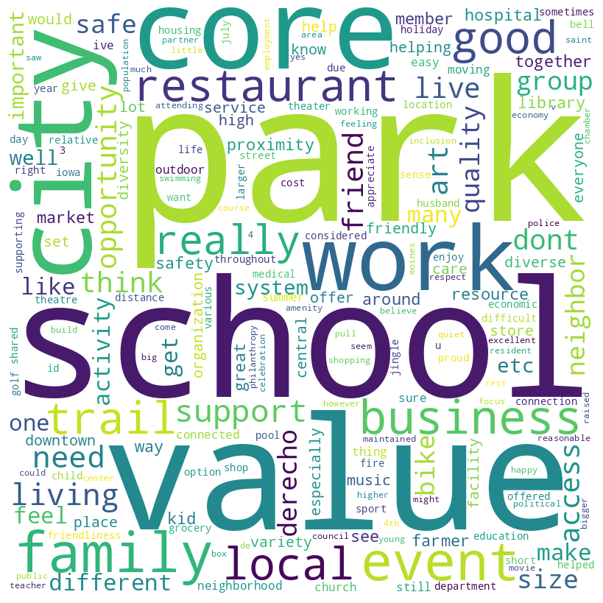

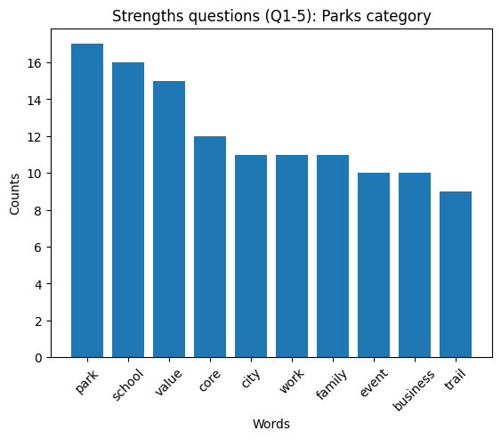

**Average sentiment of respondents of this category:**

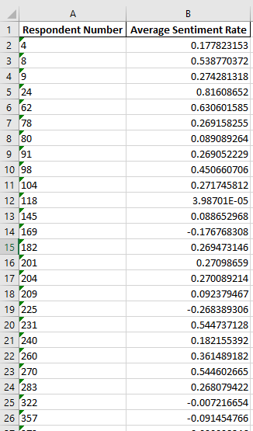

**Full file at: Final Deliverable > Issues Analysis & Deliverables > average_sentiment_parks.xlsx**

**Clusterings based on response to each question:**

Question 1: What makes you glad to live in Grinnell?

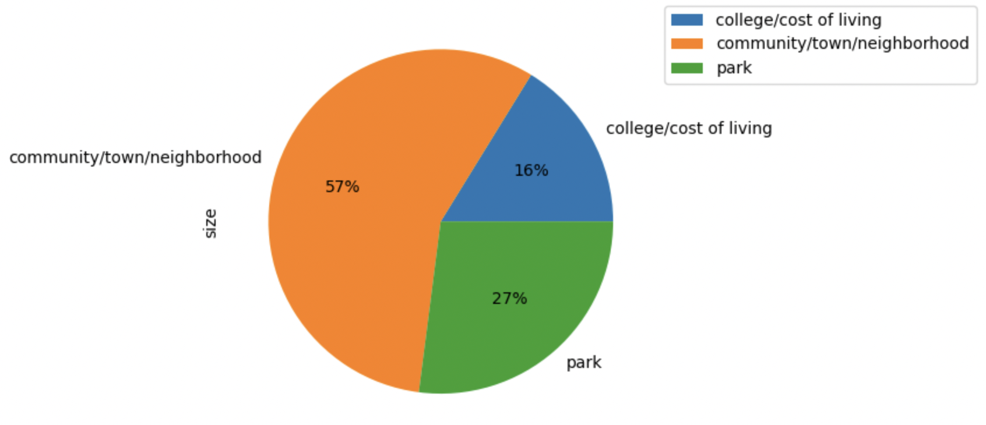

Question 2: What things have the greatest positive impact on your quality of life in Grinnell?

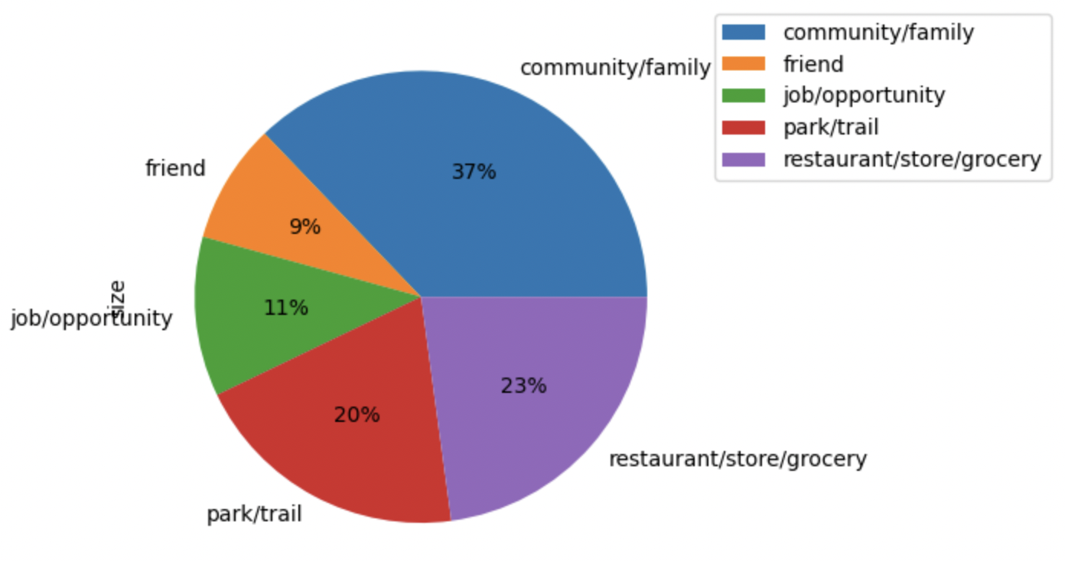

Question 10: What things have the greatest positive impact on your quality of life in Grinnell?

